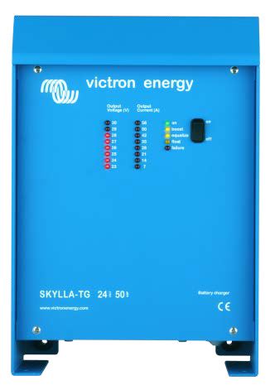
Skylla TG 24 50
Perfect chargers for any type of battery
Charge voltage can be precisely adjusted to suit any sealed or unsealed battery system.
In particular, sealed maintenance free batteries must be charged correctly in order to ensure a long service life. Overvoltage will result in excessive gassing and venting of a sealed battery. The battery will dry out and fail.

Suitable for AC and DC supply (AC-DC and DC-DC operation)
Except for the 3-phase input models, the chargers also accept a DC supply.

Controlled charging
Every TG Charger has a microprocessor, which accurately controls the charging in three steps. The charging process takes place in accordance with the IUoUo characteristic and charges more rapidly than other processes.

Use of TG Chargers as a power supply
As a result of the perfectly stabilized output voltage, a TG Charger can be used as a power supply if batteries or large buffer capacitors are not available.

Two outputs to charge 2 battery banks (24V models only)
The TG Chargers feature 2 isolated outputs. The second output, limited to approximately 4A and with a slightly lower output voltage, is intended to top up a starter battery.

To increase battery life: temperature compensation
Every Skylla TG Charger comes with a battery temperature sensor. When connected, charge voltage will automatically decrease with increasing battery temperature. This feature is especially recommended for sealed batteries which otherwise might be overcharged and dry out due to venting.

Battery voltage sense
In order to compensate for voltage loss due to cable resistance, TG Chargers are provided with a voltage sense facility so that the battery always receives the correct charge voltage.

Learn more about batteries and battery charging
To learn more about batteries and charging batteries, please refer to our book ‘Energy Unlimited’ (available free of charge from Victron Energy and downloadable from www.victronenergy.com).

www.victronenergy.com
Skylla TG Charger 24/48V

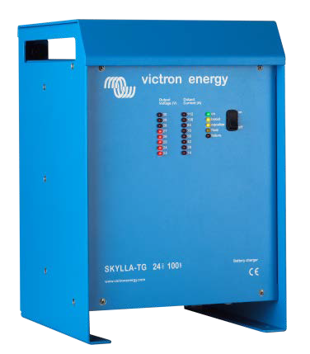

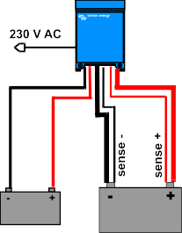
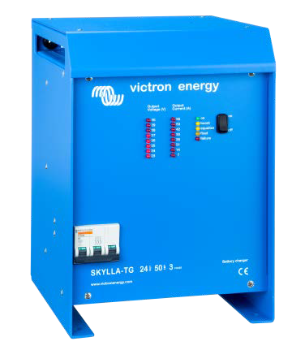Skylla TG 24 100
Skylla TG 24 50 3 phase
absorption (30 m)

U (V) 30
26,5 V
float (20 h)
float (20 h)
28,5 V

bulk
28

26
absorption (4 h)

24

I (A) 50
40
30
20
10
0

Charge curve Application example

Skylla | 24/30 TG  24/50 TG | 24/50 TG  3 phase | 24/80 TG | 24/100 TG | 24/100 TG  3 phase | 48/25 TG | 48/50 TG
Input voltage (V AC) | 230 | 3 x 400 | 230 | 230 | 3 x 400 | 230 | 230
Input voltage range (V AC) | 185-264 | 320-450 | 185-264 | 185-264 | 320-450 | 185-264 | 185-264
Input voltage range (V DC) | 180-400 | n. a. | 180-400 | 180-400 | n. a. | 180-400 | 180-400
Frequency (Hz) | 45-65
Power factor | 1
Charge voltage 'absorption' (V DC) | 28,5 | 28,5 | 28,5 | 28,5 | 28,5 | 57 | 57
Charge voltage 'float' (V DC) | 26,5 | 26,5 | 26,5 | 26,5 | 26,5 | 53 | 53
Charge current house batt. (A) (2) | 30 / 50 | 50 | 80 | 100 | 100 | 25 | 50
Charge current starter batt. (A) | 4 | 4 | 4 | 4 | 4 | n. a. | n. a.
Charge characteristic | IUoUo (three step)
Battery capacity (Ah) | 150-500 | 250-500 | 400-800 | 500-1000 | 500-1000 | 125-250 | 250-500
Temperature sensor | √
Can be used as power supply | √
Remote alarm | Potential free contacts 60V / 1A (1x NO and 1x NC)
Forced cooling | √
Protection (1) | a,b,c,d
Operating temp. range | -40 to +50°C (-40 - 122°F)
Humidity (non-condensing) | max 95%
ENCLOSURE
Material & Colour | aluminium (blue RAL 5012)
Battery-connection | M8 studs
230 V AC-connection | screw-clamp 2,5 mm² (AWG 6)
Protection category | IP 21
Weight kg (lbs) | 5,5 (12.1) | 13 (28) | 10 (22) | 10 (22) | 23 (48) | 5,5 (12.1) | 10 (12.1)
Dimensions hxwxd in mm | 365x250x147 | 365x250x257 | 365x250x257 | 365x250x257 | 515x260x265 | 365x250x147 | 365x250x257
(hxwxd in inches) | (14.4x9.9x5.8) | (14.4x9.9x10.1) | (14.4x9.9x10.1) | (14.4x9.9x10.1) | (20x10.2x10.4) | (14.4x9.9x5.8) | (14.4x9.9x10.1)
STANDARDS
Safety | EN 60335-1, EN 60335-2-29
Emission | EN 55014-1, EN 61000-3-2
Immunity | EN 55014-2, EN 61000-3-3
- Protection  - Output short circuit  - Battery reverse polarity detection  - Up to 40°C (100°F) ambient | - Battery voltage too high  - Temperature too high

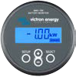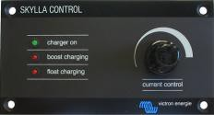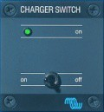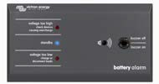

BMV-700 Battery Monitor
The BMV-700 Battery Monitor features an advanced microprocessor control system combined with high resolution measuring systems for battery voltage and charge/discharge current. Besides this, the software includes complex calculation algorithms, like Peukert’s formula, to exactly determine the state of charge of the battery. The BMV-700 selectively displays battery voltage, current, consumed Ah or time to go.
Skylla Control
The Skylla Control allows you to alter the charge current and see the system status. Altering the charge current is useful if the shore power fuse is limited: the AC current drawn by the battery charger can be controlled by limiting the maximum output current, thereby preventing the shore power fuse from blowing.
Charger Switch
A remote on-off switch
Battery Alarm
An excessively high or low battery voltage is indicated by an audible and visual alarm.

Victron Energy B.V. | De Paal 35 | 1351 JG Almere | The Netherlands General phone: +31 (0)36 535 97 00 | Fax: +31 (0)36 535 97 40
E-mail: sales@victronenergy.com | www.victronenergy.com

